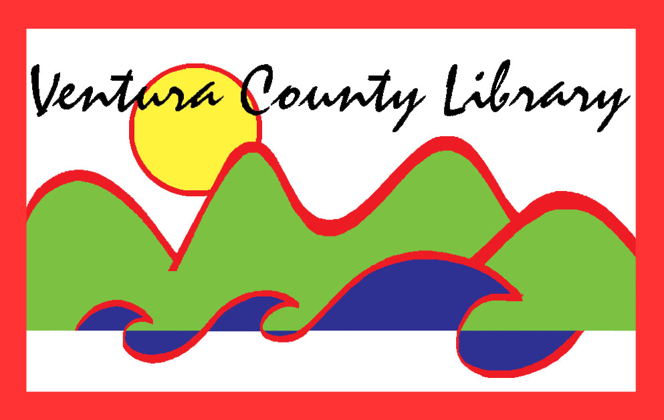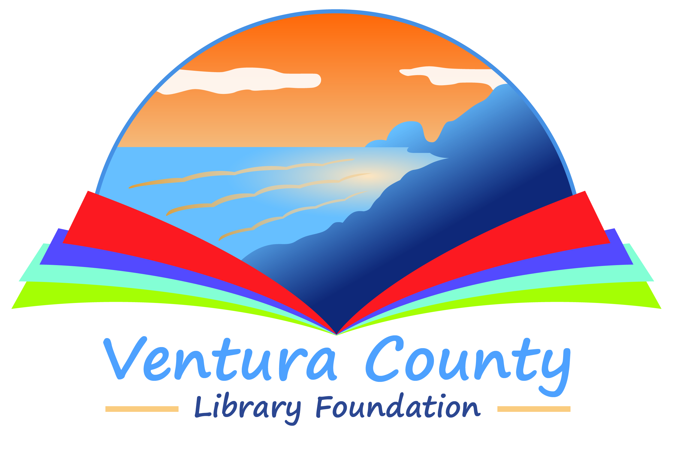

VENTURA COUNTY LIBRARY

5600 Everglades St., Suite A, Ventura, CA 93003

www.vencolibrary.org

FOR IMMEDIATE RELEASE
October 9, 2021

SUBJECT: One County, One Book 2021 Author Talk – A special event with author Steph Cha – presented virtually via Zoom
CONTACT: Nancy Schram, Ventura County Library Director, (805) 256-8535

Ron Solórzano, Regional Librarian, (805) 218-9146

DATE: Saturday, October 30, 2021; 2pm

As part of its fourth annual One County, One Book community reading program, the Ventura County Library is excited to invite all members of the public to join Steph Cha, author of Your House Will Pay, for a special author talk and Q&A. This event will take place virtually via Zoom at 2pm on October 30, 2021. Additional details about this author talk, including how to register, are posted on our website. Visit www.vencolibrary.org/ocob to register for this special event.
One County, One Book aims to unite the Ventura County community around a common narrative, spreading interest in and facilitating discussions about the selected book. This month, people across the county will have a chance to attend a variety of events related to the themes of the selection, including lectures, book clubs, and more. One County, One Book 2021 is truly a countywide initiative, and aims to spark community discussion, foster a stronger sense of community, and promote a love of reading and literature. The 2021 One County, One Book program is sponsored by the Ventura County Library Foundation.
This year’s One County, One Book selection is Your House Will Pay by Steph Cha. From the official description, Your House Will Pay is “A powerful and taut novel about racial tensions in LA, following two families—one Korean-American, one African-American—grappling with the effects of a decades-old crime.”
One County, One Book 2021 is presented by the Ventura County Library with the generous support of the Ventura County Library Foundation. Other program partners include California Lutheran University, the Museum of Ventura County, and the Ojai Valley Library Friends & Foundation.
To participate in One County, One Book, pick up a copy of Your House Will Pay from one of our 12 library branches or our Mobile Library. In addition to our regular holdings, each library will have an Honor Book Shelf set up with additional copies. You can take one of these special copies to read and return it when you are done—or pass it on to a friend. You can even donate a new copy for others!
All events associated with One County, One Book are free and open to the public. For more information about the 2021 One County, One Book program, visit www.vencolibrary.org/ocob or contact Ron Solórzano at ron.solorzano@ventura.org or (805) 218-9146.
The Ventura County Library is available 24/7 at www.vencolibrary.org. Please visit our website for information on the location and hours of the library closest to you.

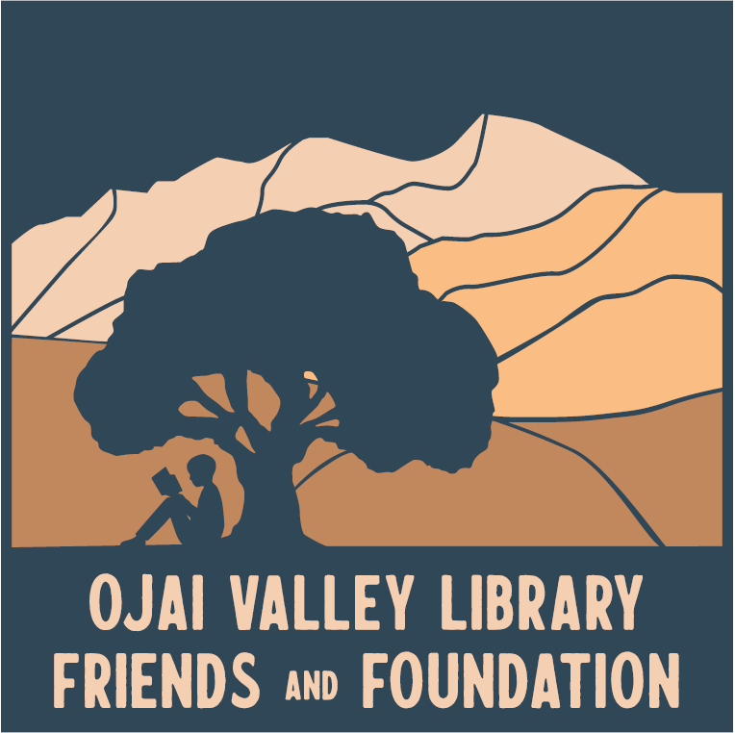

Ventura County Library:
Inspiring our community to explore, discover and connect.
The Ventura County Library is available 24/7 at www.vencolibrary.org.


Ventura County Library has 12 locations and a Mobile Library
See our hours of service at https://www.vencolibrary.org/locations
El Rio Branch:
- Albert H. Soliz Library, 2820 Jourdan Street, Oxnard, CA 93036
Heritage Valley branches:
- Fillmore Library, 502 2nd Street, Fillmore, CA 93015
- Piru Library, 3811 Center Street, Piru, CA 93040
Mobile Library https://www.vencolibrary.org/locations/mobile-library
Oak Park branch:
- Oak Park Library, 899 North Kanan Road, Oak Park, CA 91377
Ojai Valley region branches:
- Meiners Oaks Library, at Meiners Oaks Elementary, Fall 2021
- Oak View Library, 555 Mahoney Avenue, Oak View, CA 93022
- Ojai Library, 111 East Ojai Avenue, Ojai, CA 93023
Port Hueneme branch:
- Ray D. Prueter Library, 510 Park Avenue, Port Hueneme, CA 93041
Ventura region branches:
- Avenue Library, 606 North Ventura Avenue, Ventura, CA 93001
- E.P. Foster Library, 651 East Main Street, Ventura, CA 93001
- Hill Road Library, 1070 S. Hill Road, Ventura, CA 93003
- Saticoy Library, 1292 Los Angeles Avenue, Ventura, CA 93004

###

If you would prefer not to receive these event notices in the future, simply reply to this email
with UNSUBSCRIBE in the subject line.

