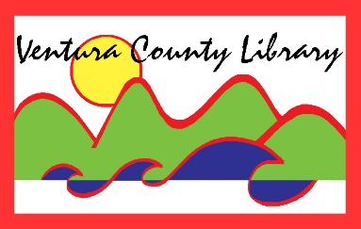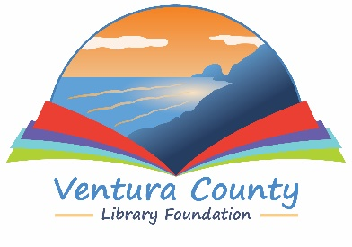

VENTURA COUNTY LIBRARY

5600 Everglades St., Suite A, Ventura, CA 93003

www.vencolibrary.org

FOR IMMEDIATE RELEASE
September 13, 2022

SUBJECT: One County, One Book 2022 – A community reading program – at the Ventura County Library
CONTACT: Nancy Schram, Ventura County Library Director, (805) 256-8535

Ron Solórzano, Regional Librarian, (805) 218-9146

Sandy Berg, snjberg@gmail.com (regarding Passports)

DATE: Author event on Saturday, November 12, 2022; additional program events available throughout October and November.

The Ventura County Library is proud to announce its fifth annual One County, One Book community reading program. One County, One Book aims to unite the Ventura County community around a common narrative, spreading interest in and facilitating discussions about the selected book. Throughout October and November, 2022, people across the county will have a chance to attend discussions and other special events related to the themes of the selection. One County, One Book 2022 is truly a countywide initiative, and aims to spark conversations, foster a stronger sense of community, and promote a love of reading and literature. The 2022 One County, One Book program is sponsored by the Ventura County Library Foundation.
This year’s One County, One Book selection is Taste Makers: Seven Immigrant Women Who Revolutionized Food in America by Mayukh Sen. Taste Makers was named Best Book of 2021 by NPR and one of the Wall Street Journal's favorite books of 2021. From the official description:
“This group biography from an electric new voice in food writing honors seven extraordinary women, all immigrants, who left an indelible mark on the way Americans eat today. Taste Makers stretches from World War II to the present, with absorbing and deeply researched portraits of figures including Mexican-born Elena Zelayeta, a blind chef; Marcella Hazan, the deity of Italian cuisine; and Norma Shirley, a champion of Jamaican dishes.”
One County, One Book culminates with a special event featuring Taste Makers’ author and NYU Adjunct Professor Mayukh Sen at 2pm on Saturday, November 12, 2022 at California State University Channel Islands’ Grand Salon. The free event is presented by the Ventura County Library with the generous support of the Ventura County Library Foundation. To offset the travel and venue expenses of the free author event, the Foundation is hosting Passports, a lively discussion with local food influencers followed by small bites representative of the food cultures in Ventura County. Passports will begin at noon in the Grand Salon. Topics ranging from County food trends to local and worldwide food issues will be led by CAPS Media Executive Director Patrick Davidson. Guests will include local restaurateur Chef Tim Kilcoyne, recently returned from Lviv, Ukraine where he served as Director of Chef Operations for World Central Kitchen, to Monica White, CEO and Executive Director of Ventura’s Food Share. Tami Chu, editor of Edible Ojai & Ventura County and Chef Adam Hart of Oxnard College’s culinary program will weigh in on local farm-to-table practices. Ukraine-raised Masha Rumer will round out the discussion on how family traditions are shared through generations of recipes and how they morph from country to country. Tickets for both events are available starting September 20 at www.vclibraryfoundation.org, free for the author event and $75 for Passports.
Along with the Foundation, One County, One Book 2022 is presented with the generous support of sponsors including Premier America Credit Union, the Ventura County Community College District, the Ventura County Star, Conejo Valley Lifestyle Magazine, Mustang Marketing, Montecito Bank & Trust, and the Ventura Friends of the Library.
Other program partners also contribute to One County, One Book by creating opportunities for community members to participate and be involved. These partners include the Museum of Ventura County, California State University Channel Islands, and California Lutheran University.
Additional One County, One Book events include a Faculty and Alumni Panel Discussion presented by California Lutheran University. Cal Lutheran will present a panel of professors and alumni—Samuel Claussen, PhD; chef Antonio Sessa ’15; and Michaela Reaves, PhD—to talk about the role of food (such as chocolate) in American history and culture. This event will take place in Cal Lutheran’s Lundring Events Center at 7pm on Thursday, October 20, 2022. For more information about the panel, contact Michaela Reaves at reaves@CalLutheran.edu or (805) 493-3381.
To participate in One County, One Book, pick up a copy of Taste Makers from one of our 12 library branches or our Mobile Library. In addition to our regular holdings, beginning in September each library will have an Honor Book Shelf set up with additional copies. You can take one of these special copies to read and return it when you are done—or pass it on to a friend. You can even donate a new copy for others!
Once you have read the book you will be ready for our October and November events. Visit our website at www.vencolibrary.org/library-events for more information as programs are scheduled.
For more information about the 2022 One County, One Book program, visit www.vencolibrary.org/ocob or contact Ron Solórzano at ron.solorzano@ventura.org or (805) 218-9146.
The Ventura County Library is available 24/7 at www.vencolibrary.org. Please visit our website for information on the location and hours of the library closest to you.

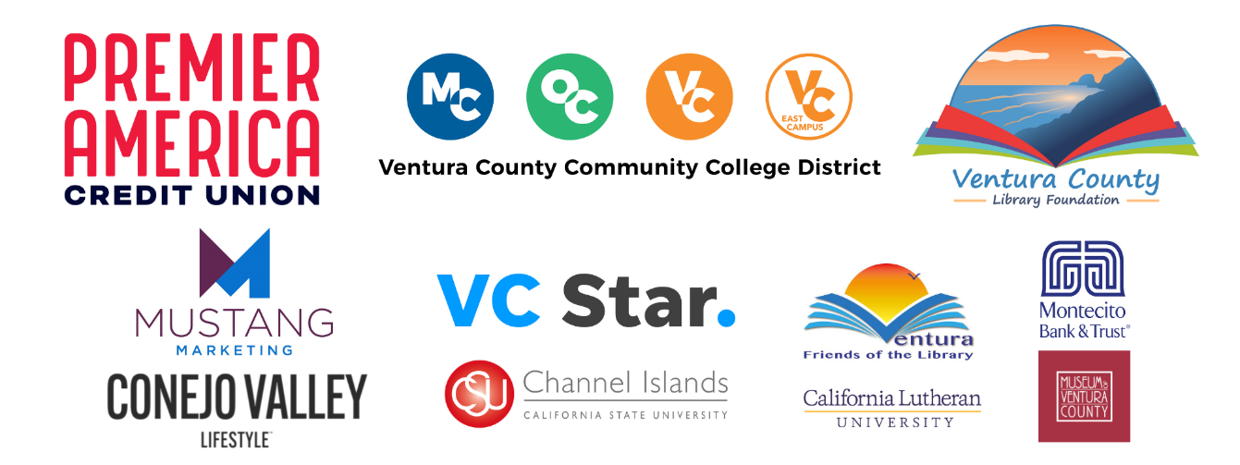

Ventura County Library:
Inspiring our community to explore, discover and connect.
The Ventura County Library is available 24/7 at www.vencolibrary.org.

Ventura County Library has 12 locations and a Mobile Library
See our hours of service at https://www.vencolibrary.org/locations
El Rio Branch:
- Albert H. Soliz Library, 2820 Jourdan Street, Oxnard, CA 93036
Heritage Valley branches:
- Fillmore Library, 502 2nd Street, Fillmore, CA 93015
- Piru Library, 3811 Center Street, Piru, CA 93040
Mobile Library https://www.vencolibrary.org/locations/mobile-library
Oak Park branch:
- Oak Park Library, 899 North Kanan Road, Oak Park, CA 91377
Ojai Valley region branches:
- Meiners Oaks Library, at Meiners Oaks Elementary, coming 2023
- Oak View Library, 555 Mahoney Avenue, Oak View, CA 93022
- Ojai Library, 111 East Ojai Avenue, Ojai, CA 93023
Port Hueneme branch:
- Ray D. Prueter Library, 510 Park Avenue, Port Hueneme, CA 93041
Ventura region branches:
- Avenue Library, 606 North Ventura Avenue, Ventura, CA 93001
- E.P. Foster Library, 651 East Main Street, Ventura, CA 93001
- Hill Road Library, 1070 S. Hill Road, Ventura, CA 93003
- Saticoy Library, 1292 Los Angeles Avenue, Ventura, CA 93004

###

If you would prefer not to receive these event notices in the future, simply reply to this email
with UNSUBSCRIBE in the subject line.

